Installation Guidelines

Lighting

DLA45 Aluminium Floor Trim

Equipment Required

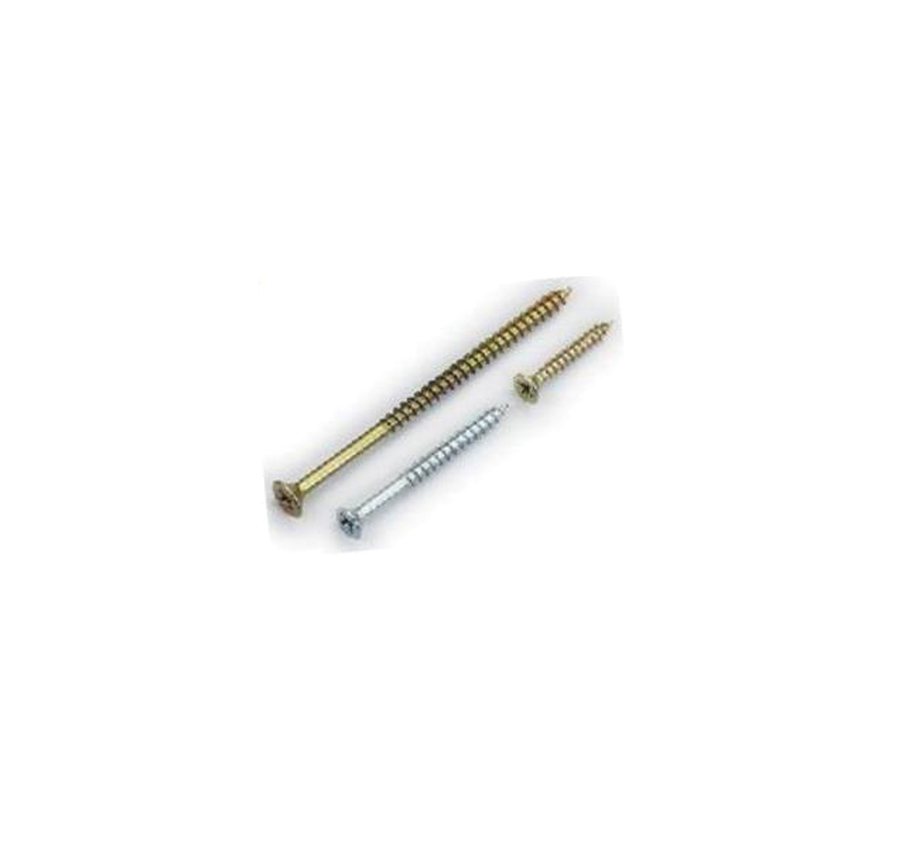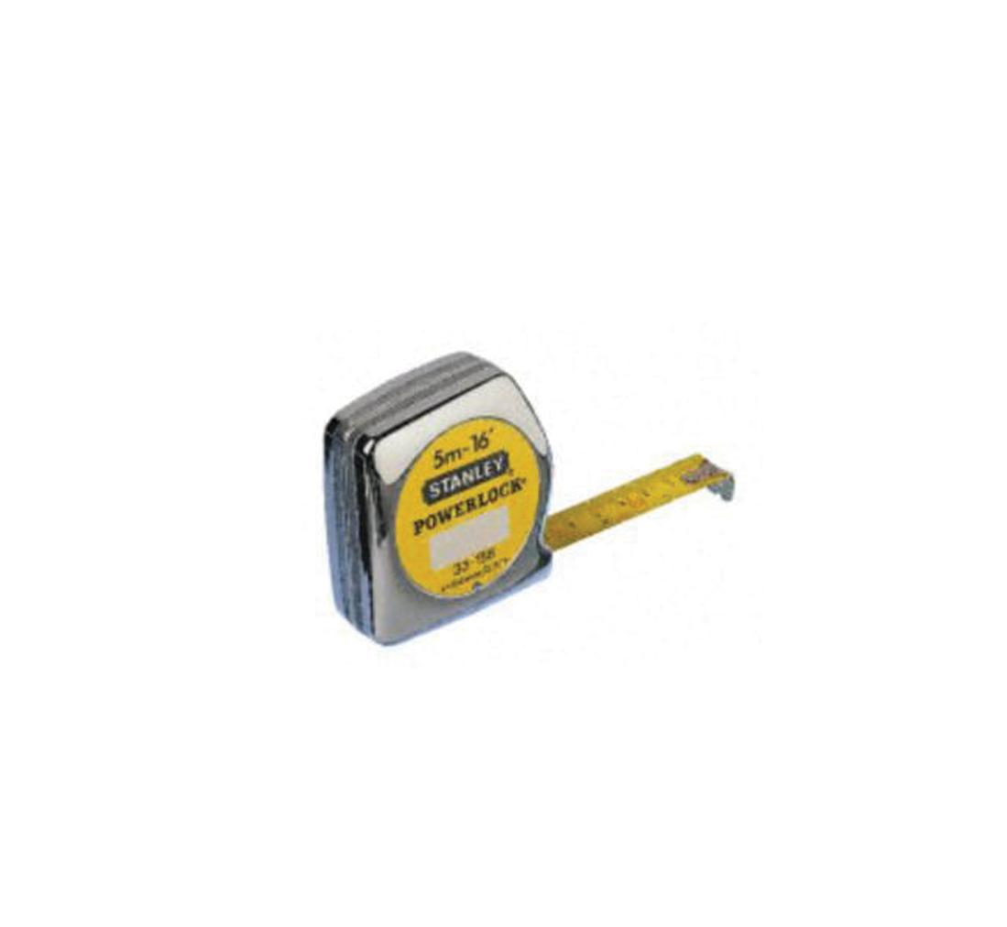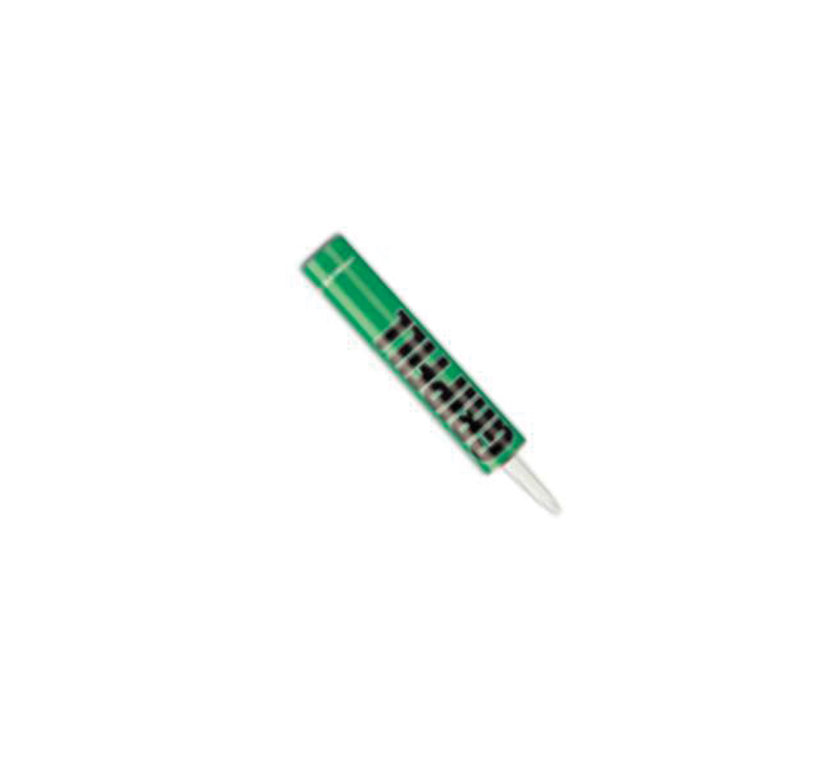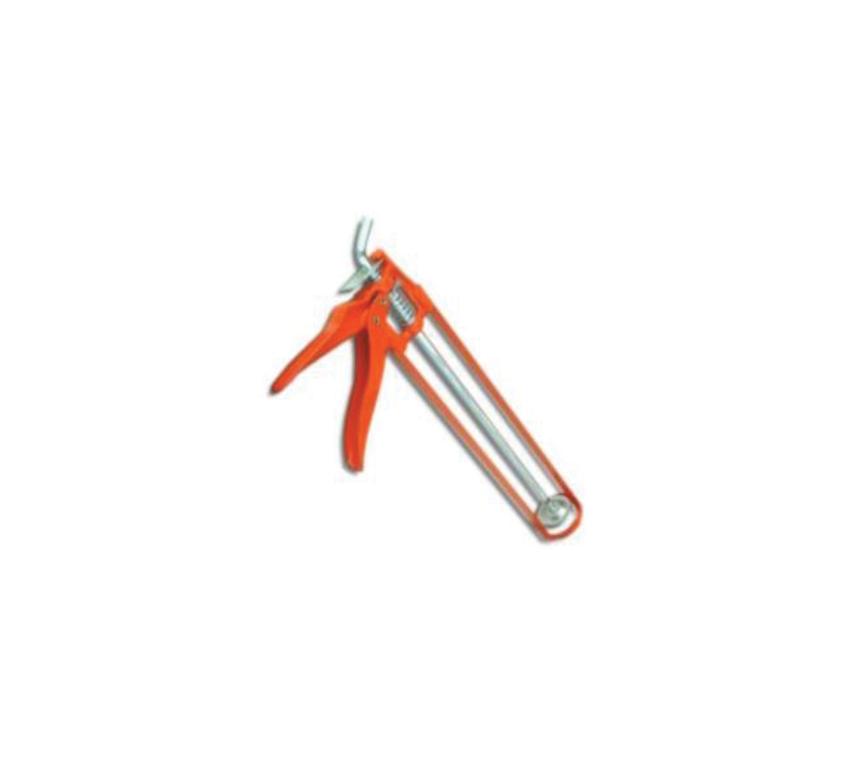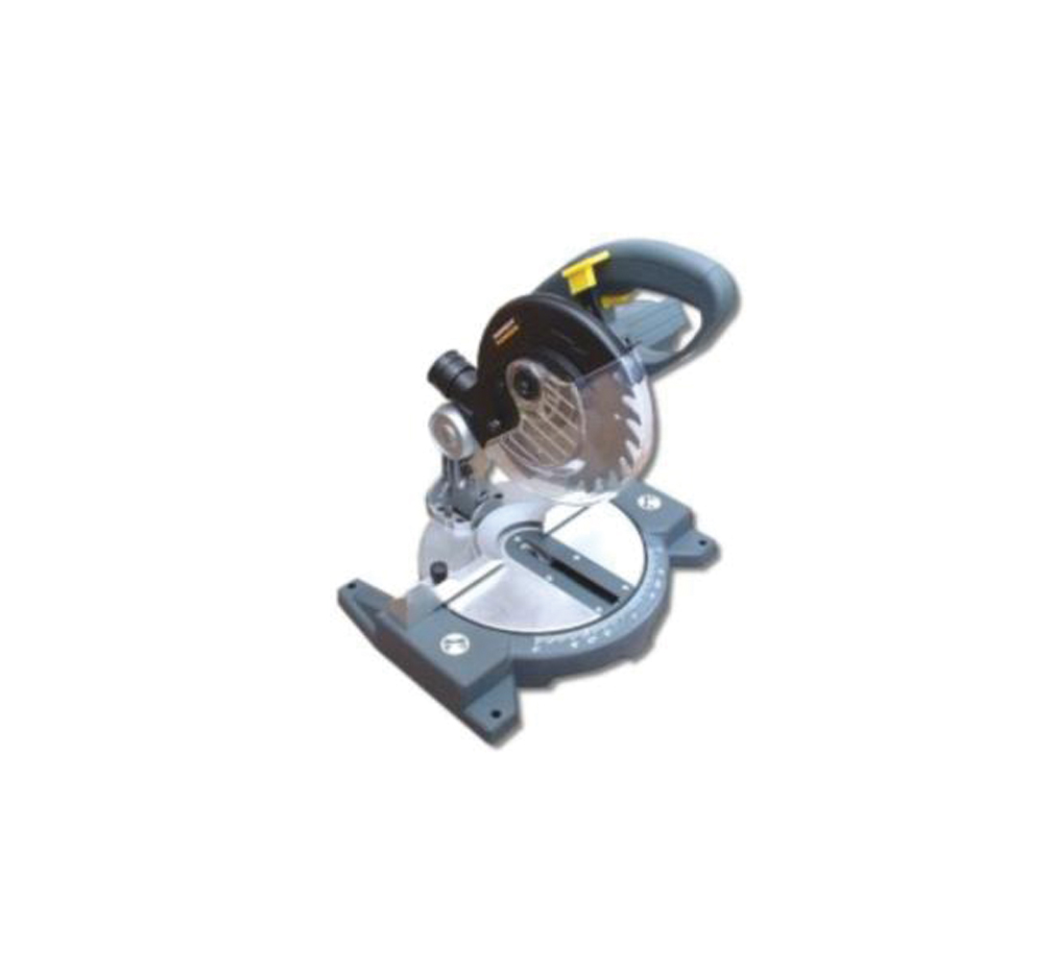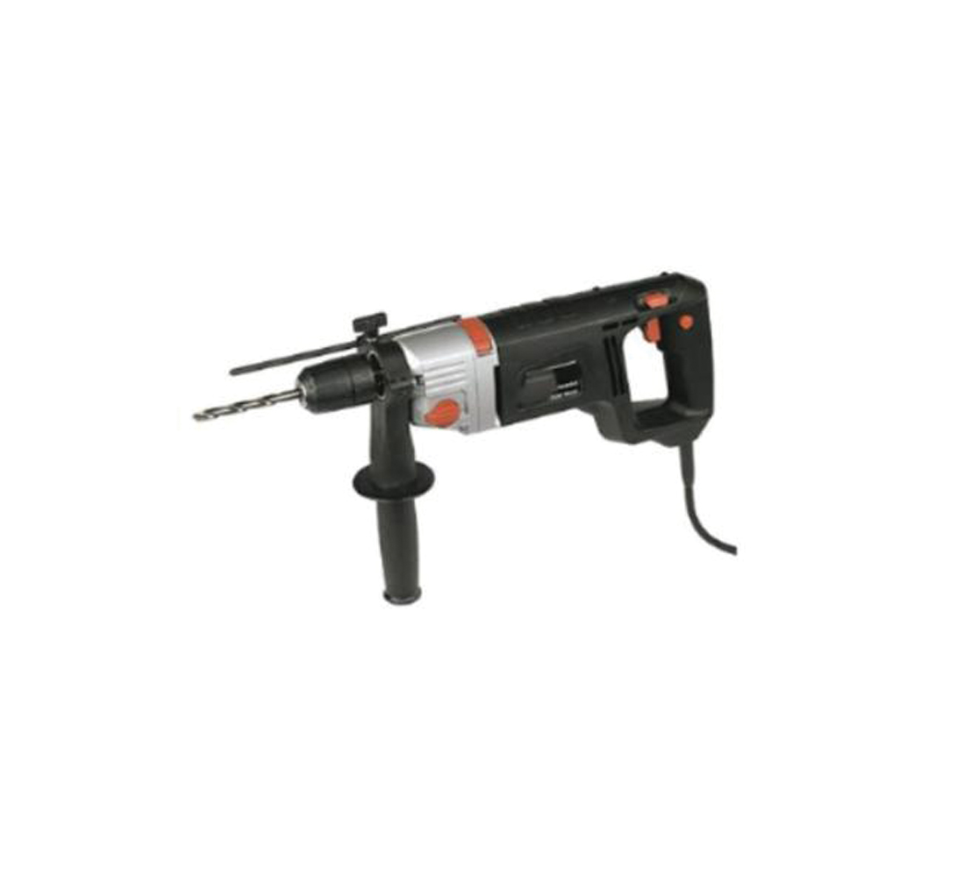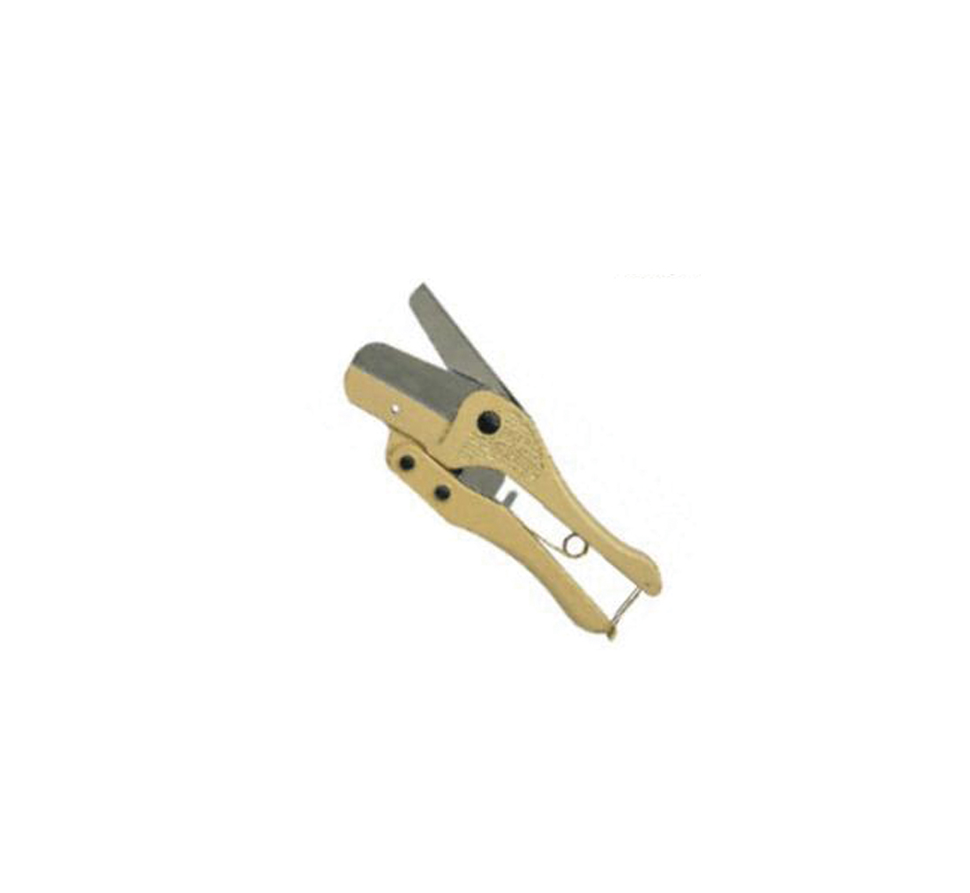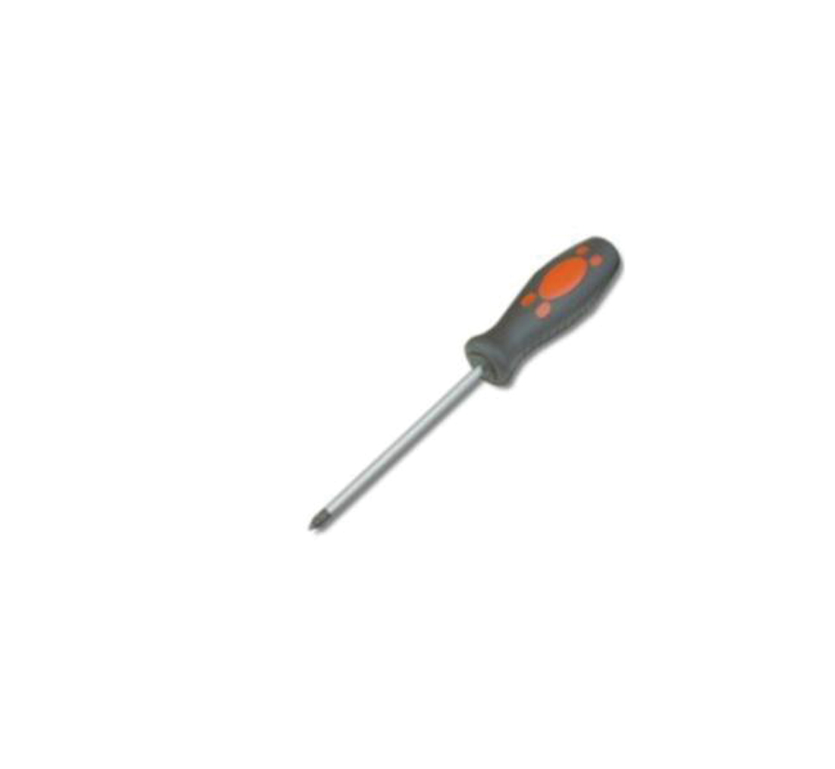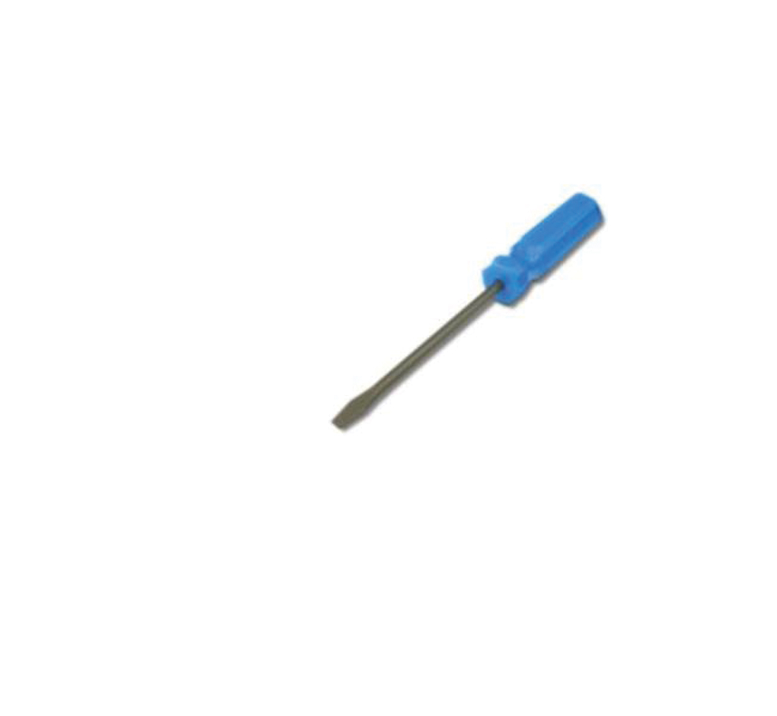

When materials are supplied, the Gradus marked packaging clearly states the product code contained within.
The power supplies are clearly marked with the input and output voltage ranges, frequency and power rating.

NB: A qualified electrician must install the power supply unit, and run cable to the junction box for the connection of the lighting.

Planning

- From the plan / drawing, calculate the length of aisle on the floor to be illuminated.

- Calculate your electrical requirements:
Interlok Advance Strips = 0..25A / 3W per metre
Continuity = 0.025A per LEDASSY

  - Circuit loading should not exceed rating of P.S.U.

  - The loading must calculated, and divided between the power supplies evenly.

  - The Power Supply units must be Class 2, 12VDC, correctly rated for the applied load.

- It is recommended that every circuit on the secondary side of the power supply is fitted with a quick blow type fuse. The rating of this fuse must be calculated to be as close as possible to the nominal current rating of the circuit.
The circuit current can be calculated from the figures given above, or preferably, taken from a site measurement with a suitable ammeter.

The number of feed points will depend on the quantity of power supplies, the location of the lighting and the volt drop of any circuit.

From the volt drop calculations, ensure if the voltage is dropping below 9V, then the lighting is refreshed from another feed point.

Voltage Drop = 65mV / A / M

Adhesives

- Where references are made to adhesives for fitting stair edgings, this should be a high performance gap filling adhesive.
- Superglue is used to hold the end caps to the stair edgings, and this should be of the cyanoacrylate type.
- Silicone sealant refers to acetoxy, silicone rubber compound equivalent to 732 RTV.
- Crimps should be the butt splice type, UL approved and suitable for 14AWG cable.


Data Sheet: (sheet 1 of 2) 18.04.11
Gradus Accessories, Park Green, Macclesfield, Cheshire SK11 7LZ England UK Tel: 01625 428922 Fax: 01625 433949
www.gradusworld.com

Mitre Saw

Tape Measure

Mastic Gun

Gap Filling Adhesive

Suitable Screws

Power Hammer Drill

PVC Conduit Cutter

Selection of Pozidrive and Slotted Screwdrivers

Installation Guidelines

Lighting

DLA45 Aluminium Floor Trim

Installation of the Floor Trim

- It should be ensured that all surfaces to which the profile is to be fixed are dry, flat and free from any contaminants.

- Cut the profile and tube to the size required.

- Place the profile into position and through the pre-drilled countersink holes, mark the substrate.

- Drill the marked substrate using a 6mm drill bit and once drilled insert the appropriate sized plug. (6mm = red plug).

- Apply a bead of proprietary cartridge adhesive to the underside of the base section, then, ensuring the substrate is free from dust, firmly place the base into position. *On timber subfloors, apply adhesive, and fix using No6 wood screws.

- Secure in place using a No6 fixing screw.

- Insert the selected lighting into the LR1238 tube, and seal the ends of the tube with silicone.

- Apply a bead of silicone into the profile, then position the tube into the profiles, ensuring the lighting and tube are correctly positioned.

- Test the installation after the silicone has gone off then connect to the power supply unit and turn on.

Note.

The profile should be installed directly onto the substrate and NOT on top of any floorcovering. The floorcovering should be abutted up to the back edge of the profile.

If any further information is required, please do not hesitate to contact Gradus Technical Services on (+44)1625 428922 or fax on (+44)1625 425226

Data Sheet: (sheet 2 of 2) 18.04.11
Gradus Accessories, Park Green, Macclesfield, Cheshire SK11 7LZ England UK Tel: 01625 428922 Fax: 01625 433949
www.gradusworld.com

